**ANALYSIS OF HOUSEHOLD WASTE MANAGEMENT PRACTICES IN DIFFERENT RESIDENTIAL DENSITY AREAS OF LAGOS, NIGERIA**

BY

**ADESOGBON DAMILOLA ADENIKE**

**MATRIC NO.: 219054031**

**A DISSERTATION SUBMITTED IN PARTIAL FULFILMENT OF THE REQUIREMENT FOR THE AWARD OF MASTER OF URBAN MANAGEMENT IN THE DEPARMENT OF URBAN AND REGIONAL PLANNING, SCHOOL OF POST GRADUATE STUDIES,**

**UNIVERSITY OF LAGOS**

**DECEMBER, 2024**

# Certification

This is to certify that this research work was carried out by Adesogbon Damilola Adenike

(219054031) of the Department of Urban and Regional Planning under the supervision of Professor Leke Oduwaye and Dr. Samson Olanrewaju.

…………………………………………… ………………………………………….

**Professor Leke Oduwaye Date**

Supervisor

…………………………………………… ………………………………………….

**Dr. T. I Salau Date**

Head of Department

# Dedication

This thesis is dedicated to God and my wonderful family and friends whose support, concern, motivation and prayers have made this work a success.

# Acknowledgements

I am grateful to Almighty God who made this project possible. I express my sincere gratitude to my supervisors, Professor Leke Oduwaye and Dr. Samson Olanrewaju. Thier advice, logic and support are invaluable and made possible the accomplishment of this study. I appreciate the members of staff, Department of Urban and Regional Planning, University of Lagos, for their support on my academics. I also appreciate the Urban Lab WitsTUB Unilag and the DAAD scholarship committee for the opportunity given to men. To my parents, Mr. and Mrs. Babatunde and Janet Adesogbon, thank you for your love and honour.

Add as many people as you wish.

You can choose to make it lengthy.

**Adesogbon Damilola Adenike**

**December, 2024**

# List of Figures

# List of Charts

Table of Contents

Certification ii

Dedication iv

Acknowledgements v

List of Figures vi

List of Charts vii

Abstract 5

CHAPTER ONE 6

INTRODUCTION 6

1.0 Background to the study 6

1.2 Statement of Problem 8

1.3 Research Questions 11

1.4 Aim and Objectives of the Study 12

1.4.1 Aim of the Study 12

1.4.2 Objectives of the Study 12

1.5 Justification of the Study 12

1.6 Scope and Limitations of the Study 14

1.6.1 Scope of the Study 14

1.6.2 Limitations of the Study 15

1.7 Study Area 17

1.7.1 Mushin 17

1.7.2 Oniru 18

1.7.3 Yaba 19

1.8 Contribution to Knowledge 19

1.9 Definition of Key Variables 21

CHAPTER TWO 24

LITERATURE REVIEW AND CONCEPTUAL FRAMEWORK 24

2.1 Literature Review 24

2.1.1 Urban Waste Management Challenges 24

2.1.2 Socioeconomic Factors and Waste Management 25

2.1.3 Public Awareness and Participation 25

2.1.4 Policy and Governance Frameworks 26

2.1.5 Sustainability and Environmental Justice 27

2.2 Conceptual Framework 27

2.2.1 Key Components of the Conceptual Framework 27

2.2.2 Relationships Between Components 29

2.2.3 Theoretical Underpinnings 30

2.2.4 Implications for Research and Practice 31

CHAPTER THREE 32

RESEARCH METHODOLOGY 32

3.0 Methodology 32

3.1 Research Design 32

3.2 Study Area 32

3.3 Data Collection Methods 33

3.3.1 Primary Data Collection 33

3.3.2 Secondary Data Collection 34

3.4 Data Analysis 35

3.4.1 Quantitative Data Analysis 37

3.4.2 Qualitative Data Analysis 37

3.5 Sample Size and Sampling Technique 38

3.6 Ethical Considerations 39

3.7 Limitations of the Study 39

CHAPTER FOUR 40

DISCUSSION OF FINDINGS 40

4.1 SOCIO-ECONOMIC CHARACTERISTICS 42

4.1.1 Distribution of Respondents by Residential Area 42

4.1.2 Distribution of Respondents by Age Group 43

4.1.3 Gender Distribution 44

4.1.4 Employment Types of Respondents 45

4.1.5 Distribution of Respondents by Monthly Income Bracket 46

4.2 WASTE MANAGEMENT PRACTICES 47

4.2.1 Types of Household Waste Generated per Area 47

4.2.2 Methods of Waste Disposal by Residential Area 49

4.2.3 Waste Collection Frequency by Residential Area 50

4.2.4 Waste Segregation Practices by Residential Area 51

4.3 FACTORS INFLUENCING WASTE MANAGEMENT PRACTICES 52

4.3.1 Awareness and Usage of Recycling Facilities by Residential Area 52

4.3.2 Training on Waste Management 53

4.1 Effectiveness of Existing Waste Management Strategies 54

4.4.3 Correlation Between Income Level and Waste Practices 58

4.5.2 Willingness to Participate in Community Programs 60

4.5.3 Proposed Solutions for Waste Management Challenges 61

CHAPTER FIVE 66

SUMMARY OF FINDINGS, RECOMMENDATIONS AND CONCLUSION 66

5.1 Summary of Findings 66

5.2 Recommendations 68

5.3 Conclusion 69

References 76

# Abstract

*This study examines waste management practices across three distinct residential areas in Lagos, Nigeria: Mushin, Yaba, and Oniru. Using a purposive sampling technique, the research targeted 60 respondents per community, with a total of 161 valid responses obtained. The study explores the types of waste generated, waste disposal methods, recycling and segregation practices, and the socio-economic and infrastructural factors influencing these practices.*

*The findings reveal significant disparities across the three communities. Mushin predominantly relies on informal waste disposal methods such as open dumping and burning, reflecting inadequate infrastructure and low public awareness. Yaba exhibits a transitional state, with a mix of formal and informal practices, while Oniru demonstrates higher adoption of formal systems, including consistent waste segregation and recycling, facilitated by better infrastructure and higher awareness levels.*

*Statistical analyses highlight significant relationships between residential areas and practices such as waste segregation and recycling. The study identifies key challenges, including limited access to facilities, inconsistent waste collection, and low levels of community engagement in Mushin and Yaba. Conversely, Oniru's higher engagement in sustainable practices serves as a model for addressing these issues.*

*The study concludes with recommendations to enhance waste management practices, including increased resource allocation, public awareness campaigns, provision of recycling facilities, and integration of informal waste collectors into formal systems. These localized strategies aim to promote sustainable waste management and environmental equity across Lagos.*

# CHAPTER ONE

# INTRODUCTION

## 1.0 Background to the study

Effective waste management is vital to urban health, environmental sustainability, and economic resilience. It involves the systematic collection, transport, processing, recycling, and disposal of waste to mitigate its adverse impacts on human health and the environment (United Nations Environment Programme, 2019). In Lagos, one of Africa’s most rapidly urbanizing cities, waste management poses unique challenges due to high population density and infrastructural constraints. This study focuses on Mushin and Oniru as case areas, assessing key variables such as waste generation, segregation, recycling rates, and public awareness.

Waste generation is a critical concern, reflecting the total volume of waste produced by each community (World Bank, 2018). Waste segregation—separating waste into categories—optimizes processing efficiency and reduces landfill pressure, while recycling rates measure how much waste is diverted from traditional disposal paths and reprocessed for reuse (Global Recycling Foundation, 2021). Public awareness, essential for community engagement in waste practices, is a further determinant of waste management effectiveness, as it influences the adoption of sustainable waste disposal habits (Ali & Sia, 2020).

The issue of waste management has emerged as a critical challenge in urban areas worldwide, particularly in developing countries. Rapid urbanization, coupled with population growth, has led to an unprecedented increase in waste generation. According to the World Bank, urban areas in developing countries generate approximately 1.3 billion tons of solid waste annually, a figure projected to rise to 2.2 billion tons by 2025 (Hoornweg & Bhada-Tata, 2012). In Lagos, Nigeria, the situation is particularly alarming, with the city generating an estimated 40 million tons of municipal solid waste each year (Adebola, 2009). This translates to approximately 10,000 tons of waste generated daily, placing immense pressure on the existing waste management infrastructure.

The consequences of inadequate waste management are severe. Poor waste disposal practices contribute to public health risks, including the spread of diseases such as cholera and malaria, particularly in low-income neighborhoods where sanitation services are often lacking (Adelekan, 2010). Environmental degradation is another significant concern, as improperly managed waste can lead to soil and water contamination, as well as air pollution from open burning (Ogunwande et al., 2018). Furthermore, the economic implications of ineffective waste management are substantial, with costs associated with health care, environmental cleanup, and lost productivity.

Globally, various strategies have been implemented to tackle waste management challenges. Integrated waste management systems, which promote waste reduction, recycling, and recovery, have gained traction in many countries. For instance, Sweden has achieved a recycling rate of over 60% by implementing comprehensive recycling programs and investing in waste-to-energy technologies (European Commission, 2018). Similarly, Germany has established a successful dual system for packaging waste, which has significantly increased recycling rates and reduced landfill use (Meyer, 2015).

Public awareness campaigns and community engagement initiatives have also proven effective in fostering responsible waste disposal behaviors. Research indicates that community-based social marketing can lead to significant improvements in recycling rates and waste reduction (McKenzie-Mohr, 2011). Countries like Japan have implemented educational programs that emphasize the importance of waste segregation and recycling, resulting in high levels of public participation in waste management efforts (Kawai & Tasaki, 2016).

In Nigeria, and specifically in Lagos, efforts to improve waste management have faced numerous challenges. The Lagos State Government has initiated several programs aimed at enhancing waste collection and disposal services, including the establishment of the Lagos Waste Management Authority (LAWMA) and the introduction of the Cleaner Lagos Initiative (CLI) (Lagos State Government, 2018). However, these initiatives have often been hampered by inadequate infrastructure, insufficient funding, and a lack of public awareness regarding proper waste management practices.

Disparities in waste management practices across different neighborhoods in Lagos further complicate the situation. Areas like Mushin, characterized by high population density and low-income households, often rely on informal waste disposal methods, leading to significant environmental and health risks (Ogunwande et al., 2018). In contrast, more affluent areas like Oniru benefit from better waste management services and higher levels of public awareness. This uneven distribution of resources and services highlights the need for targeted interventions that consider the unique socio-economic and infrastructural contexts of each area.

## 1.2 Statement of Problem

Waste management in Lagos State, Nigeria, has emerged as a critical challenge exacerbated by rapid urbanization, population growth, and inadequate infrastructure. The city generates approximately 10,000 tons of waste daily, yet the existing waste management systems are insufficient to handle this volume effectively. The consequences of poor waste management are dire, leading to public health risks, environmental degradation, and economic losses. Despite various efforts by government entities and community organizations to address these challenges, significant gaps remain in the implementation and effectiveness of waste management practices.

At the federal level, the Nigerian government has established policies aimed at promoting sustainable waste management practices. The National Environmental (Sanitation and Wastes Control) Regulations were introduced to provide a framework for waste management across the country. However, enforcement remains weak, and many local governments lack the capacity to implement these regulations effectively. The absence of a cohesive national strategy has resulted in fragmented efforts that fail to address the unique challenges faced by urban areas like Lagos.

At the State level, the Lagos State Government has initiated several programs, including the establishment of the Lagos Waste Management Authority (LAWMA) and the Cleaner Lagos Initiative (CLI). These initiatives aim to improve waste collection, enhance recycling efforts, and promote public awareness. However, critiques of these programs highlight issues such as inadequate funding, insufficient infrastructure, and a lack of community engagement. For instance, while LAWMA has made strides in waste collection, many residents still rely on informal waste disposal methods due to inconsistent service delivery and limited access to waste management facilities.

At the Local level, community-based waste management initiatives have emerged as a response to the inadequacies of formal systems. Local governments have attempted to implement waste segregation programs and community clean-up campaigns. However, these efforts often suffer from a lack of resources, training, and public participation. Many residents remain unaware of the importance of waste segregation, leading to low participation rates in local initiatives. Furthermore, the reliance on informal waste collectors perpetuates poor waste management practices, as these collectors may not adhere to proper disposal methods.

Community efforts to address waste management challenges in Lagos have included grassroots organizations and non-governmental organizations (NGOs) that promote awareness and engage residents in waste reduction practices. Initiatives such as community clean-up days and educational workshops have been implemented to encourage responsible waste disposal and recycling. However, these efforts often face challenges related to sustainability and scalability. Many community organizations operate on limited budgets and rely heavily on volunteer participation, which can fluctuate over time. Additionally, without support from local government authorities, these initiatives may struggle to achieve long-term impact.

Recent research has highlighted the importance of community involvement in waste management, emphasizing that participatory approaches can lead to more effective and sustainable outcomes (McKenzie-Mohr, 2021). However, studies also indicate that community efforts alone are insufficient to address the systemic issues plaguing waste management in Lagos. A lack of coordination between community organizations and government agencies can lead to duplicated efforts and wasted resources.

Recent studies on waste management practices in Lagos have focused on various aspects, including waste generation patterns, public awareness, and the effectiveness of existing policies. Research has shown that socioeconomic factors significantly influence waste management outcomes, with low-income communities often facing greater challenges in accessing waste management services (Ogunwande et al., 2018). Additionally, studies have identified a lack of empirical data on the effectiveness of specific waste management strategies in different neighborhoods, highlighting the need for localized research that considers the unique contexts of areas like Mushin, Yaba, and Oniru.

Despite the growing body of literature, significant gaps remain in understanding the interplay between socio-economic factors and waste management practices in Lagos. There is a need for comparative studies that evaluate the effectiveness of waste management strategies across different urban locales, as well as research that explores the role of community engagement in enhancing waste management outcomes.

This study aims to fill the existing gaps in the literature by conducting a comparative analysis of waste management practices in Mushin, Yaba, and Oniru. By examining the specific challenges and opportunities within these contrasting urban settings, the research seeks to provide valuable insights that can inform more effective and sustainable waste management strategies in Lagos. The study will evaluate the effectiveness of current waste management practices, assess the influence of socio-economic factors, and explore the role of community engagement in promoting responsible waste disposal behaviors.

Furthermore, this research will contribute to the understanding of how localized interventions can be tailored to address the unique needs of different communities, ultimately supporting evidence-based policy interventions that enhance urban sustainability in Lagos. By synthesizing findings from existing research and incorporating community perspectives, this study aims to provide a comprehensive overview of waste management practices in Lagos State, contributing to the development of targeted strategies that promote sustainable waste management.

## 1.3 Research Questions

1. What are the current waste management practices in Mushin, Yaba and Oniru?
2. What key factors influence waste management practices in Mushin, Yaba and Oniru?
3. How effective are the existing waste management strategies in Mushin, Yaba and Oniru?
4. What challenges do residents, waste management personnel, and policymakers face in implementing and adhering to waste management practices in Mushin, Yaba and Oniru?

## 1.4 Aim and Objectives of the Study

### 1.4.1 Aim of the Study

The primary aim of this research is to explore and compare the waste management practices in selected residential areas of Lagos, to understand the specific challenges and opportunities in these contrasting urban settings.

### 1.4.2 Objectives of the Study

1. To assess the current waste management practices in Mushin, Yaba and Oniru, including waste collection, segregation, recycling, and disposal methods.
2. To identify the key factors influencing waste management practices in these areas, such as socioeconomic status, public awareness, and infrastructure availability.
3. To evaluate the effectiveness of existing waste management strategies in Mushin and Oniru, with a focus on their environmental, social, and economic impacts.
4. To understand the challenges faced by residents, waste management personnel, and policymakers in implementing and adhering to waste management practices in these areas.

## 1.5 Justification of the Study

Effective waste management is a critical component of urban sustainability, significantly impacting public health, environmental quality, and economic resilience. In rapidly urbanizing cities like Lagos, Nigeria, the challenges associated with waste management are particularly pronounced due to high population density, inadequate infrastructure, and varying socio-economic conditions. This study focuses on Mushin, Yaba and Oniru, three contrasting urban settings within Lagos, to provide a nuanced understanding of waste management practices and their implications.

The justification for this study is multifaceted. First, as Lagos continues to grow, the volume of waste generated increases, leading to significant environmental and public health concerns. By examining the waste management practices in Mushin, Yaba and Oniru, this study aims to identify specific challenges faced by these communities, thereby contributing to the broader discourse on urban sustainability and resilience.

Second, the contrasting socio-economic profiles of Mushin, Yaba and Oniru present an opportunity to explore how these differences influence waste management practices. Understanding these disparities is essential for developing targeted interventions that address the unique needs of each community, ensuring that waste management strategies are equitable and effective.

Moreover, the findings of this study will provide valuable insights for policymakers, urban planners, and waste management practitioners. By identifying strengths and weaknesses in current waste management practices, the research aims to inform evidence-based policy interventions that can enhance waste management systems in Lagos. This is particularly important in a context where existing policies may not adequately address the complexities of urban waste management.

Additionally, effective waste management requires active participation from residents. By assessing public awareness and attitudes towards waste management in Mushin, Yaba and Oniru, this study seeks to highlight the importance of community engagement in fostering sustainable waste practices. Empowering communities to take ownership of waste management initiatives can lead to improved outcomes and greater accountability.

Finally, there is a paucity of comparative studies examining waste management practices within different urban locales in Lagos. This research aims to fill this gap by providing empirical insights into the dynamics of waste management in Mushin, Yaba and Oniru. The findings will contribute to the academic literature on urban waste management, offering a framework for future research in similar contexts.

## 1.6 Scope and Limitations of the Study

### 1.6.1 Scope of the Study

This study is focused on a comparative analysis of waste management practices in three distinct urban areas of Lagos State, Nigeria: Mushin, Yaba and Oniru. By examining these communities, the research aims to explore various dimensions of waste management while considering their unique socio-economic, cultural, and infrastructural contexts.

The geographical scope of the study is limited to the residential areas of Mushin, Yaba and Oniru, which represent contrasting population densities and socio-economic conditions. Mushin is characterized by its high population density and vibrant markets, Yaba is known for its moderately populated density, while Oniru is known for its upscale residential environment and relatively lower population density. This geographical focus allows for a detailed examination of how these differences influence waste management practices.

The study will investigate several key aspects of waste management, including types of waste generated, waste collection, segregation, recycling, and disposal methods. It will assess the effectiveness of existing waste management strategies in both areas and identify the factors that contribute to their success or failure.

In addition to waste management practices, the research will delve into the socio-economic characteristics of residents in both Mushin, Yaba and Oniru. This includes examining income levels, education, and public awareness regarding waste management. Understanding these socio-economic factors is crucial for analyzing how they impact waste management behaviors and practices within each community.

Public awareness and attitudes towards waste management will also be a significant focus of the study. The research will assess residents' knowledge of waste segregation, recycling practices, and their overall engagement in waste management initiatives.

Furthermore, the availability and quality of waste management infrastructure and services will be evaluated. This includes looking at the frequency of waste collection, the presence of recycling facilities, and the adequacy of waste disposal sites in both areas.

The study will also identify the unique challenges faced by residents, waste management personnel, and policymakers in implementing effective waste management practices in Mushin and Oniru. Alongside these challenges, the research will explore potential opportunities for improvement and innovation in waste management strategies.

Finally, based on the findings, the study will propose context-specific recommendations aimed at enhancing waste management practices in both communities. These recommendations will be tailored to address the specific needs and circumstances of Mushin and Oniru, promoting sustainable waste management solutions.

### 1.6.2 Limitations of the Study

This study, while aiming to provide a comprehensive analysis of waste management practices in Mushin, Yaba and Oniru, is subject to several limitations that may affect the findings and their generalizability. Recognizing these limitations is crucial for understanding the context and implications of the research.

Firstly, the geographical scope of the study is confined to three specific areas within Lagos State. This limitation means that the findings may not fully represent the diverse waste management practices found in other neighborhoods or regions of the city. The unique socio-economic and cultural characteristics of Mushin, Yaba and Oniru may restrict the applicability of the results to other areas with different contexts.

Additionally, the research may rely on a limited sample size of residents, waste management personnel, and policymakers. This could introduce bias and affect the reliability of the data collected. A broader sample that encompasses various demographics would provide a more comprehensive understanding of waste management practices.

The data collection methods employed in the study may also pose limitations. The reliance on qualitative methods, such as interviews and surveys, can be subject to respondent bias, potentially leading to inaccuracies in the data. Self-reported information may not fully capture the extent of individuals' engagement in waste management initiatives, as respondents might overstate their involvement.

Temporal constraints further limit the research, as it is conducted within a specific timeframe. This may not account for seasonal variations in waste generation and management practices. The dynamics of waste management can change over time due to factors such as population growth, urban development, and shifts in policy, which may not be fully captured in a single study.

Moreover, while the study aims to evaluate existing waste management strategies, it may not delve deeply into the broader policy framework governing waste management in Lagos State. A more comprehensive analysis of policy implications and governance structures could provide additional insights into the effectiveness of waste management practices.

The socio-economic variability within the selected areas also presents a limitation. The factors influencing waste management practices may differ significantly among residents, and the study may not fully capture the nuances of these variations, particularly in communities with diverse income levels and educational backgrounds.

Furthermore, there is a potential for observer bias, as the researchers' perspectives and interpretations may inadvertently influence the analysis of data. Although efforts will be made to minimize bias, it is important to acknowledge that subjective interpretations can affect the conclusions drawn from the study.

Lastly, the research may not account for external factors such as government policies, economic fluctuations, or environmental changes that could impact waste management practices. These external influences may affect the findings and limit the ability to draw definitive conclusions.

## 1.7 Study Area

The study focuses on three distinct neighborhoods within Lagos State, Nigeria: Mushin, Yaba and Oniru. These areas were selected due to their contrasting socio-economic characteristics, urban environments, and waste management practices, which provide a rich context for comparative analysis.

### 1.7.1 Mushin

Mushin is a densely populated urban area known for its vibrant commercial activities and diverse residential communities. It is characterized by a mix of low to middle-income households, with a significant portion of the population engaged in informal economic activities. The area faces challenges related to inadequate infrastructure, including limited waste management services and insufficient public awareness regarding waste segregation and recycling. The high population density in Mushin exacerbates waste generation, leading to significant challenges in waste collection and disposal. The socio-economic conditions in Mushin often result in a lack of resources for effective waste management, making it a critical area for examining the impacts of socio-economic factors on waste practices.

### 1.7.2 Oniru

Oniru, in contrast, is an upscale neighborhood that reflects a different socio-economic landscape. It is known for its affluent residents, well-planned infrastructure, and better access to waste management services. The area has a higher level of public awareness regarding environmental issues, including waste segregation and recycling. Oniru's residents are generally more engaged in sustainable waste management practices, supported by the availability of resources and facilities for recycling and proper waste disposal. The differences in socio-economic status and infrastructure between Oniru and Mushin provide a unique opportunity to explore how these factors influence waste management outcomes.

By focusing on these two neighborhoods, the study aims to highlight the disparities in waste management practices and the underlying factors that contribute to these differences. The comparative analysis will shed light on the challenges faced by residents, waste management personnel, and policymakers in each area, ultimately informing targeted interventions for improving waste management in Lagos State. Understanding the dynamics of waste management in Mushin and Oniru is essential for developing context-specific strategies that address the unique needs and circumstances of each community, thereby contributing to more sustainable urban environments.

### 1.7.3 Yaba

Yaba is a commercial and residential center with markets, tech hubs, and educational institutions, making it representative of diverse urban activities that generate waste.

With a moderate population density, Yaba generates significant amounts of residential and commercial waste, offering rich data for analysis. The area hosts people from varying socio-economic backgrounds, providing insights into how waste management practices differ among various demographic groups.

The mix of informal settlements, middle-class neighborhoods, and commercial zones reflects waste management challenges across income levels. Choosing Yaba ensures a focused yet diverse lens for understanding waste management challenges in urban Nigerian contexts, while also exploring innovative and scalable solutions.

## 1.8 Contribution to Knowledge

This study on the comparative analysis of waste management practices in Mushin, Yaba and Oniru makes significant contributions to the existing body of knowledge in several important areas.

Firstly, it enhances our understanding of urban waste management dynamics by examining three neighborhoods with contrasting socio-economic profiles. This research reveals how socio-economic factors influence waste management practices, highlighting the complexities of urban waste management in a rapidly urbanizing context like Lagos. The diverse population densities and economic conditions in these areas lead to varying waste generation and disposal behaviors, providing valuable insights into the challenges and opportunities present in different urban settings.

Secondly, the study identifies best practices in waste management, particularly those employed in Oniru, an upscale neighborhood. By contrasting these effective strategies with the challenges faced in Mushin, the research not only sheds light on successful waste management practices but also offers a framework for adapting and implementing these strategies in lower-income areas. The findings serve as a reference for policymakers and waste management authorities seeking to enhance waste management systems across diverse urban environments.

Moreover, the research highlights critical issues of environmental justice by documenting disparities in waste management services and practices between different socio-economic groups. This focus on social equity emphasizes the need for equitable waste management solutions that address the specific needs of marginalized communities, contributing to the discourse on environmental justice and fostering inclusive urban development.

The practical implications of this study are significant for policymakers and waste management practitioners. By providing context-specific recommendations based on the unique challenges and opportunities identified in Mushin, Yaba and Oniru, the research can inform the design and implementation of targeted interventions aimed at improving waste management practices. This contribution is particularly relevant in Lagos, where effective waste management is essential for public health and environmental sustainability.

Additionally, the study lays the groundwork for future research in urban waste management by highlighting the need for comparative analyses across different neighborhoods and cities. It encourages further exploration of the relationships between socio-economic factors, public awareness, and waste management practices, inspiring subsequent studies to investigate other areas within Lagos or similar urban contexts. This expansion of research can deepen our understanding of waste management challenges and solutions.

Finally, by emphasizing the role of community engagement in effective waste management, the study contributes to the growing body of literature on participatory approaches in environmental governance. It advocates for the inclusion of local knowledge and social networks in the development of waste management strategies, thereby enhancing the sustainability and effectiveness of interventions.

## 1.9 Definition of Key Variables

Waste management encompasses a range of activities aimed at the collection, transportation, processing, recycling, and disposal of waste materials. Key variables in this study include:

* + **Waste Generation**: This refers to the total amount of waste produced by a community, typically measured in tons per day. In urban settings, waste generation is influenced by factors such as population density, economic activity, and consumption patterns.
  + **Waste Segregation**: This is the process of separating waste into different categories (e.g., organic, recyclable, hazardous) at the point of disposal. Effective waste segregation is crucial for enhancing recycling rates and reducing the volume of waste sent to landfills.
  + **Recycling Rates**: This variable indicates the percentage of waste that is diverted from landfills and processed for reuse. High recycling rates are indicative of effective waste management practices and community engagement.
  + **Public Awareness**: This refers to the level of understanding and knowledge that residents have regarding waste management practices, their importance, and the impact of waste on health and the environment. Public awareness is essential for fostering responsible waste disposal behaviors.

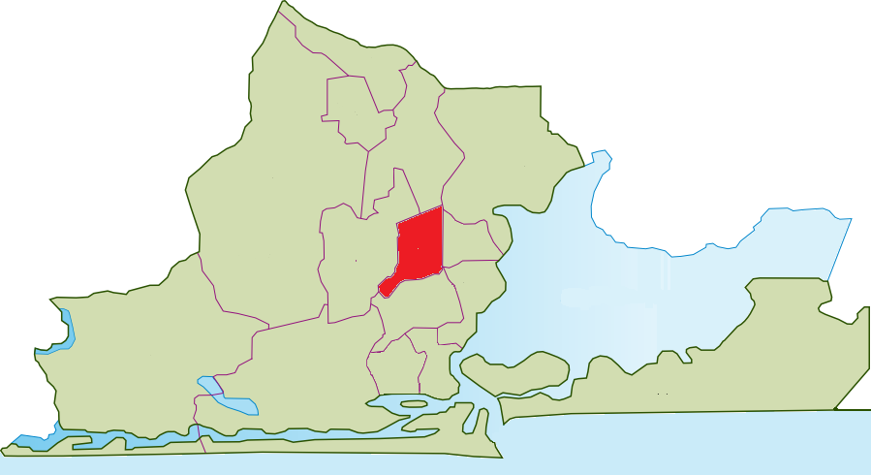

Plate 1: Map of Mushin, Lagos

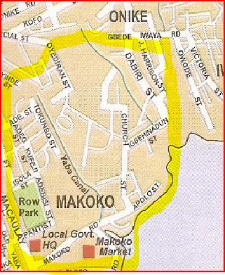

Plate 2: Map of Yaba, Lagos

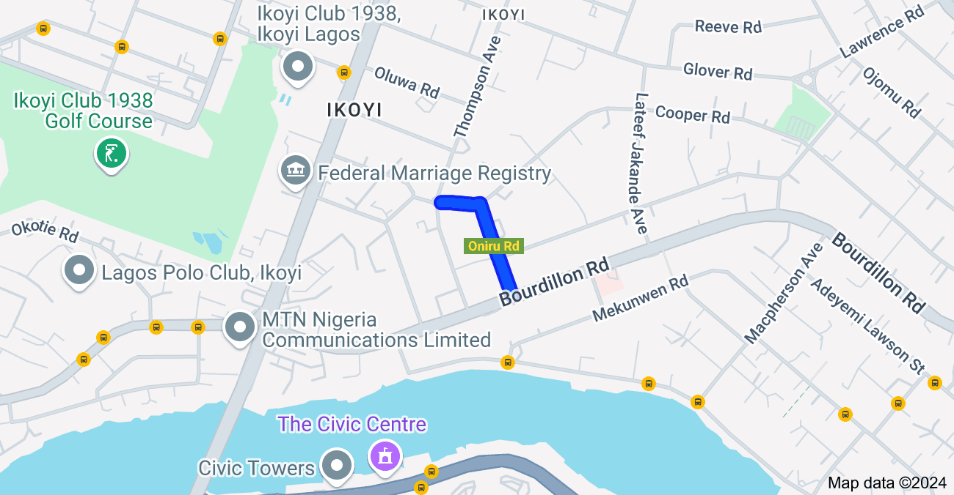

Plate 3: Map of Oniru, Lagos

# CHAPTER TWO

# LITERATURE REVIEW AND CONCEPTUAL FRAMEWORK

## 2.1 Literature Review

The literature review for this comparative analysis of waste management practices in Lagos State delves into existing research, theoretical frameworks, and empirical studies that illuminate the complexities of urban waste management. It synthesizes findings from various sources to identify key themes, challenges, and opportunities in waste management, particularly in the context of rapidly urbanizing cities like Lagos.

### 2.1.1 Urban Waste Management Challenges

Urban waste management is a pressing issue in many developing countries, where rapid urbanization and population growth significantly increase the volume of waste generated. According to Hoornweg and Bhada-Tata (2012), cities in developing regions are expected to generate 1.3 billion tons of solid waste annually by 2025, with a substantial portion coming from urban areas. In Lagos, Adebola (2009) estimates that the city generates approximately forty million tons of municipal solid waste each year, a figure that underscores the urgent need for effective waste management strategies.

The challenges associated with waste management in Lagos are multifaceted. Inadequate infrastructure, limited financial resources, and insufficient public awareness exacerbate these issues. For instance, the existing waste management systems often struggle to cope with the sheer volume of waste, leading to inefficient disposal practices and environmental degradation. Research by Wilson et al. (2015) highlights that many urban areas lack the necessary facilities for waste segregation, recycling, and safe disposal, resulting in increased pollution and health risks for residents. Furthermore, the lack of comprehensive waste management policies and enforcement mechanisms contributes to the persistence of these challenges.

### 2.1.2 Socioeconomic Factors and Waste Management

Socioeconomic status is a critical determinant of waste management practices. Research indicates that wealthier neighborhoods, such as Oniru, typically have better waste management infrastructure and services compared to lower-income areas like Mushin. Tchobanoglous et al. (1993) argue that higher-income areas often have more resources for waste segregation, recycling, and proper disposal, leading to more effective waste management outcomes. Conversely, lower-income neighborhoods may face significant barriers, including limited access to waste management services, inadequate infrastructure, and a lack of public awareness about proper waste disposal practices.

Zhang et al. (2010) emphasize that socioeconomic disparities can lead to higher rates of illegal dumping and inadequate waste disposal in poorer communities. This disparity highlights the need for targeted interventions that consider the unique socioeconomic contexts of different neighborhoods. For instance, community-based programs that provide education and resources for waste management in lower-income areas can help bridge the gap and promote more sustainable practices.

### 2.1.3 Public Awareness and Participation

Public awareness and community engagement are essential components of effective waste management. The literature emphasizes the importance of educating residents about waste segregation, recycling, and the environmental impacts of improper waste disposal. Kumar et al. (2017) found that communities with higher levels of awareness and education about waste management practices tend to exhibit better compliance and participation in waste management initiatives.

Participatory approaches that involve community members in decision-making processes have been shown to enhance the effectiveness of waste management initiatives. Bennett et al. (2013) argue that fostering a sense of ownership and responsibility among residents can lead to improved compliance with waste management practices. For example, community-led clean-up campaigns and awareness programs can empower residents to take an active role in managing their waste, ultimately leading to better environmental outcomes.

### 2.1.4 Policy and Governance Frameworks

Effective waste management requires robust policy frameworks and governance structures. The literature highlights the role of government policies in shaping waste management practices, including regulations on waste segregation, recycling incentives, and public-private partnerships. Pérez et al. (2015) note that comprehensive waste management policies are essential for addressing the complexities of urban waste management and ensuring that all communities have access to adequate services.

In Lagos, the Lagos State Waste Management Authority (LAWMA) has implemented various initiatives aimed at improving waste management, yet challenges remain in enforcement and compliance. Studies suggest that strengthening institutional frameworks and enhancing collaboration between government agencies, private sector stakeholders, and communities are essential for achieving sustainable waste management outcomes (Morrissey & Browne, 2004). For instance, effective public-private partnerships can leverage resources and expertise to improve waste collection and recycling efforts.

### 2.1.5 Sustainability and Environmental Justice

The concept of sustainability is central to discussions of waste management, particularly in urban contexts. The literature emphasizes the need for integrated waste management approaches that prioritize resource efficiency, pollution prevention, and environmental justice. Schroeder et al. (2018) argue that sustainable waste management practices not only address environmental concerns but also promote social equity by ensuring that all communities have access to clean and healthy environments.

Research indicates that marginalized communities often bear the brunt of environmental degradation resulting from inadequate waste management practices. This inequity underscores the importance of addressing social justice issues within the framework of waste management. Studies have shown that inclusive waste management policies that consider the needs of vulnerable populations can lead to more equitable outcomes and improved public health (Scheinberg et al., 2010).

## 2.2 Conceptual Framework

The conceptual framework for this study on waste management practices in Lagos State, specifically in the contrasting urban settings of Mushin. Yaba and Oniru, serves as a guiding structure that outlines the key variables, relationships, and theoretical underpinnings that inform the research. This framework is essential for understanding the complexities of waste management and the factors that influence its effectiveness in different socio-economic contexts.

### 2.2.1 Key Components of the Conceptual Framework

The conceptual framework is built around several interrelated components that capture the dynamics of waste management practices. These components include:

* + **Socioeconomic Factors**: This component examines how socioeconomic status influences waste management practices. Variables such as income level, education, and employment status are critical in determining residents' access to waste management services and their participation in waste segregation and recycling initiatives. Higher socioeconomic status often correlates with better waste management infrastructure and services, while lower-income areas may face significant barriers.
  + **Public Awareness and Education**: Public awareness plays a crucial role in shaping waste management behaviors. This component focuses on the level of knowledge and understanding that residents have regarding waste segregation, recycling, and the environmental impacts of waste. Educational initiatives and community engagement programs are essential for fostering a culture of responsible waste management.
  + **Institutional Frameworks and Governance**: Effective waste management is closely tied to the institutional and governance structures in place. This component explores the role of government policies, regulations, and the effectiveness of waste management authorities. It also considers the collaboration between public and private sectors, as well as community involvement in decision-making processes.
  + **Environmental Sustainability**: This component emphasizes the importance of sustainable waste management practices that minimize environmental impact. It includes considerations of waste reduction, recycling, and proper disposal methods. The framework recognizes that sustainable practices contribute to public health, environmental quality, and overall urban livability.
  + **Community Engagement and Participation**: Community involvement is a critical factor in the success of waste management initiatives. This component examines how participatory approaches can empower residents to take ownership of waste management practices. Engaging communities in decision-making processes fosters a sense of responsibility and can lead to more effective waste management outcomes.

### 2.2.2 Relationships Between Components

The conceptual framework illustrates the relationships between the various components, highlighting how they interact to influence waste management practices:

* + **Socioeconomic Factors and Public Awareness**: Higher socioeconomic status often leads to greater access to education and resources, resulting in increased public awareness about waste management. Conversely, lower socioeconomic status may limit access to information and resources, leading to lower levels of awareness and participation in waste management initiatives.
  + **Public Awareness and Community Engagement**: Increased public awareness can enhance community engagement in waste management practices. When residents understand the importance of waste segregation and recycling, they are more likely to participate in community-led initiatives and adhere to waste management policies.
  + **Institutional Frameworks and Community Engagement**: Effective governance and institutional frameworks are essential for fostering community engagement. Policies that promote public participation in waste management decision-making can lead to more tailored and effective waste management strategies that address the specific needs of different communities.
  + **Environmental Sustainability and Institutional Frameworks**: The effectiveness of waste management practices is influenced by the institutional frameworks in place. Strong governance structures that prioritize environmental sustainability can lead to the implementation of effective waste reduction, recycling, and disposal strategies.

### 2.2.3 Theoretical Underpinnings

The conceptual framework is grounded in several theoretical perspectives that inform the understanding of waste management practices:

* + **Systems Theory**: This theory posits that waste management is a complex system composed of interrelated components, including social, economic, and environmental factors. Understanding the interactions between these components is essential for developing effective waste management strategies.
  + **Social Capital Theory**: This theory emphasizes the importance of social networks and community engagement in achieving collective goals. In the context of waste management, strong social capital can enhance community participation and foster collaborative efforts to improve waste management practices.
  + **Environmental Justice Theory**: This theory highlights the need for equitable access to environmental resources and services. It underscores the importance of addressing disparities in waste management practices between different socioeconomic groups, ensuring that all communities have access to effective waste management services.

### 2.2.4 Implications for Research and Practice

The conceptual framework provides a comprehensive understanding of the factors influencing waste management practices in Lagos State. It guides the research design and methodology, ensuring that the study addresses critical variables and relationships. The insights gained from this framework can inform policymakers, urban planners, and waste management practitioners in developing targeted interventions that consider the unique needs and circumstances of different communities.

By focusing on the interplay between socioeconomic factors, public awareness, institutional frameworks, environmental sustainability, and community engagement, the study aims to contribute valuable insights that can enhance waste management practices in Lagos. Ultimately, the conceptual framework serves as a foundation for understanding the complexities of waste management and the pathways to achieving more sustainable and equitable outcomes in urban environments.

# CHAPTER THREE

# RESEARCH METHODOLOGY

## 3.0 Methodology

This chapter outlines the research design, data collection methods, and analytical techniques employed in the comparative analysis of waste management practices in Mushin, Yaba, and Oniru, Lagos State. The methodology is structured to ensure that the study effectively addresses the research objectives and provides reliable and valid insights into the waste management practices in these contrasting urban settings.

## 3.1 Research Design

The study adopts a mixed-methods research design, combining both qualitative and quantitative approaches. This design is chosen to provide a comprehensive understanding of the waste management practices in the selected areas by capturing both statistical data and the lived experiences of residents and stakeholders. The mixed-methods approach allows for triangulation of data, enhancing the validity of the findings.

## 3.2 **Study Area**

The research focuses on three distinct areas within Lagos State: Mushin, Yaba, and Oniru. These areas were selected based on their contrasting socio-economic characteristics, population density, and waste management practices.

* + **Mushin**: A densely populated area characterized by informal settlements and lower socio-economic status. Waste management challenges in this area are exacerbated by limited infrastructure and public awareness.
  + **Yaba**: A transitional area with a mix of residential and commercial activities. Yaba is known for its educational institutions and emerging tech hubs, which influence waste generation and management practices.
  + **Oniru**: An upscale area with better infrastructure and higher socio-economic status. Waste management practices in Oniru are expected to be more organized, reflecting the residents' capacity and awareness regarding waste management.

## 3.3 Data Collection Methods

Data collection for this study involves both primary and secondary sources.

### 3.3.1 Primary Data Collection

* + **Surveys**: Structured questionnaires will be administered to residents in the three areas to gather quantitative data on waste generation, disposal practices, and perceptions of waste management services. The survey will include questions on:
    - Demographic information (age, gender, income level, education)
    - Waste generation patterns (types and quantities of waste produced)
    - Waste disposal methods (household practices, use of waste collection services)
    - Awareness and attitudes towards recycling and waste management policies

A stratified random sampling technique will be employed to ensure representation across different socio-economic groups within each area. The sample size will be determined based on the population of each area, aiming for a confidence level of 95% and a margin of error of 5%.

* + **Interviews**: Semi-structured interviews was be conducted with key stakeholders, including waste management personnel, local government officials, and community leaders. These interviews provided qualitative insights into the challenges and opportunities in waste management practices. The interview guide will cover topics such as:
    - Institutional frameworks and policies governing waste management
    - Community engagement and participation in waste management initiatives
    - Perceived barriers to effective waste management

### 3.3.2 Secondary Data Collection

Secondary data will be gathered from existing literature, government reports, and relevant studies on waste management practices in Lagos State. This data will provide context and background information to support the primary data findings. Key sources will include:

* + Academic journals and articles on waste management
  + Reports from government agencies and NGOs involved in waste management
  + Statistical data on waste generation and management in Lagos State

## 3.4 Data Analysis

|  |  |  |  |
| --- | --- | --- | --- |
| **Objective** | **Specific Questions** | **Types of Data** | **Methods of Analysis** |
| **Objective 1:**  Assess the current waste management practices in Mushin, Yaba, and Oniru. | - What are the current waste management practices in these areas?   - How do waste collection, segregation, recycling, and disposal methods vary across the three locations? | * Questionnaire data on waste management habits    - Observational data from field visits | - Descriptive statistics  - Comparative analysis |
| **Objective 2:** Evaluate the key factors influencing waste management practices in these areas. | - What socio-economic factors influence waste management practices?  - How does public awareness and infrastructure availability affect waste management? | - Survey data on socio-economic status and public awareness  - Infrastructure data | - Cross-tabulations  - Inferential statistics |
| **Objective 3:** Analyze the effectiveness of existing waste management strategies in Mushin, Yaba, and Oniru. | - How effective are the current waste management strategies in terms of environmental, social, and economic impacts?  - What are the strengths and weaknesses of these strategies? | - Data from surveys and interviews with residents and waste management personnel   - Policy documents and reports | - Thematic analysis   - Content analysis |
| **Objective 4:** Understand the challenges faced by residents, waste management personnel, and policymakers. | - What challenges do residents face in adhering to waste management practices?   - How do waste management personnel and policymakers perceive the challenges in implementing waste management strategies? | - Semi-structured interview data   - Observational data from field visits | - Qualitative data analysis (e.g., thematic analysis)   - Narrative analysis |

### 3.4.1 Quantitative Data Analysis

Quantitative data collected from surveys was analyzed using statistical software (i.e. Excel). The analysis included:

* + Descriptive statistics to summarize demographic information and waste generation patterns.
  + Inferential statistics (e.g., chi-square tests) to identify significant differences in waste management practices across the three areas.
  + Correlation analysis to explore relationships between socio-economic factors and waste management behaviors.

### 3.4.2 Qualitative Data Analysis

Qualitative data from interviews was analyzed using thematic analysis. This process involves:

* + Transcribing recorded interviews and discussions.
  + Coding the data to identify recurring themes and patterns related to waste management practices.
  + Interpreting the findings to provide insights into the socio-political dynamics and community engagement in waste management.

## 3.5 Sample Size and Sampling Technique

Given the comparative nature of this study, a purposive sampling technique was adopted to ensure the inclusion of respondents from all three study locations: Mushin, Yaba, and Oniru. This approach was chosen to allow for an in-depth comparison of waste management practices across these distinct communities, each characterized by unique socio-economic and infrastructural attributes.

The study aimed to collect an equal number of responses from each location, targeting **60 responses per area**, resulting in a total planned sample size of **180 respondents**. This even distribution was designed to facilitate a balanced comparison of waste management practices and challenges between the communities. However, due to time constraints and logistical challenges, the actual number of responses collected totaled **161**, distributed as follows:

* **Mushin**: 55 responses
* **Yaba**: 52 responses
* **Oniru**: 54 responses

While the final sample size fell short of the initial target, the collected data remains representative of the study areas and provides sufficient depth for meaningful analysis. Efforts were made to ensure diversity within each community by including respondents across various age groups, income levels, and employment statuses, thereby capturing a wide range of perspectives on waste management practices.

This purposive approach allowed the study to focus on the specific characteristics of each community, ensuring the findings are reflective of their distinct waste management dynamics and challenges. Despite the reduced sample size, the study’s insights remain robust and valuable for understanding the comparative waste management practices in Mushin, Yaba, and Oniru.

## 3.6 Ethical Considerations

Ethical considerations are paramount in conducting this research. The following measures will be implemented:

* 1. Informed consent will be obtained from all participants before data collection, ensuring they understand the purpose of the study and their right to withdraw at any time.
  2. Anonymity and confidentiality will be maintained by assigning unique identifiers to participants and securely storing data.
  3. The study will adhere to ethical guidelines set forth by relevant institutional review boards and research ethics committees.

## 3.7 Limitations of the Study

While this study aims to provide a comprehensive analysis of waste management practices, certain limitations may affect the findings:

* 1. The reliance on self-reported data from surveys and interviews may introduce bias, as participants may provide socially desirable responses.
  2. The study's focus on three areas may limit the generalizability of the findings to other regions in Lagos State or Nigeria.
  3. Time and resource constraints may affect the depth of data collection and analysis.

.

# CHAPTER FOUR

# DISCUSSION OF FINDINGS

This chapter presents a detailed analysis of the data collected during the study, focusing on waste management practices in Mushin, Yaba, and Oniru. It examines the socio-economic characteristics of respondents, the types of household waste generated, methods of waste disposal, and the effectiveness of existing waste management systems. The chapter also explores the factors influencing waste management practices, such as public awareness, infrastructure availability, and community engagement. By comparing the findings across the three neighborhoods, this chapter provides insights into the unique challenges and opportunities that shape waste management outcomes in Lagos.

The study aimed to collect an equal number of responses from each location, targeting **60 responses per area**, resulting in a total planned sample size of **180 respondents**. This even distribution was designed to facilitate a balanced comparison of waste management practices and challenges between the communities. However, due to time constraints and logistical challenges, the actual number of responses collected totaled **161**, distributed as follows:

* **Mushin**: 55 responses
* **Yaba**: 52 responses
* **Oniru**: 54 responses

While the final sample size fell short of the initial target, the collected data remains representative of the study areas and provides sufficient depth for meaningful analysis. Efforts were made to ensure diversity within each community by including respondents across various age groups, income levels, and employment statuses, thereby capturing a wide range of perspectives on waste management practices.

This purposive approach allowed the study to focus on the specific characteristics of each community, ensuring the findings are reflective of their distinct waste management dynamics and challenges. Despite the reduced sample size, the study’s insights remain robust and valuable for understanding the comparative waste management practices in Mushin, Yaba, and Oniru.

## 4.1 SOCIO-ECONOMIC CHARACTERISTICS

### 4.1.1 Distribution of Respondents by Residential Area

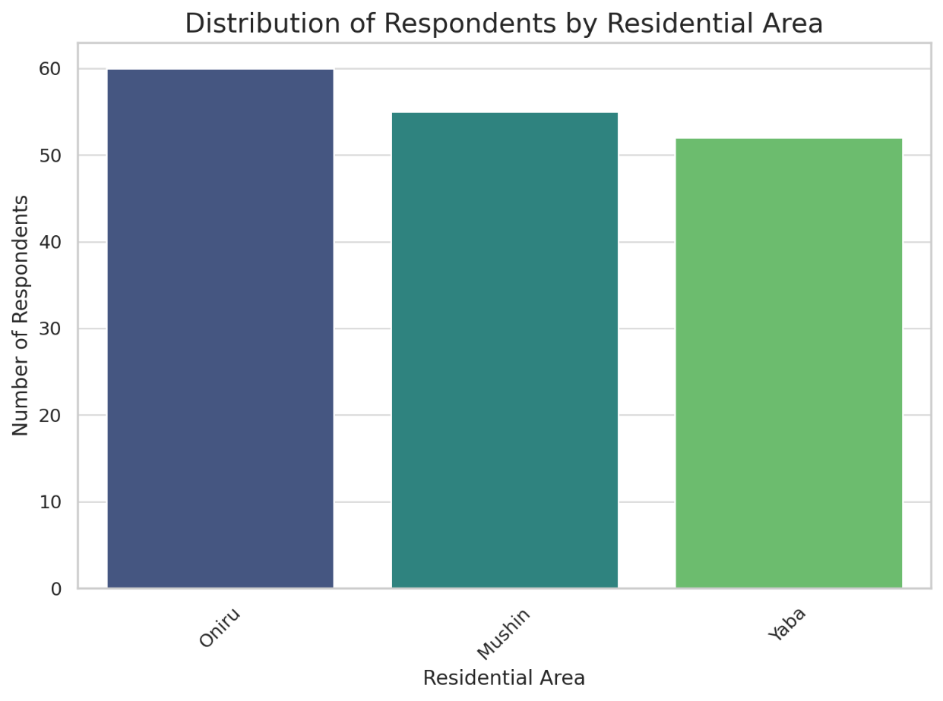

The bar chart illustrates the distribution of respondents across the three residential areas under study: Mushin, Yaba, and Oniru. Each bar represents the count of individuals surveyed in a specific area, providing a comparative view of respondent representation. Oniru had 60 respondents, Yaba had 52, while Mushin had 55.

### 4.1.2 Distribution of Respondents by Age Group

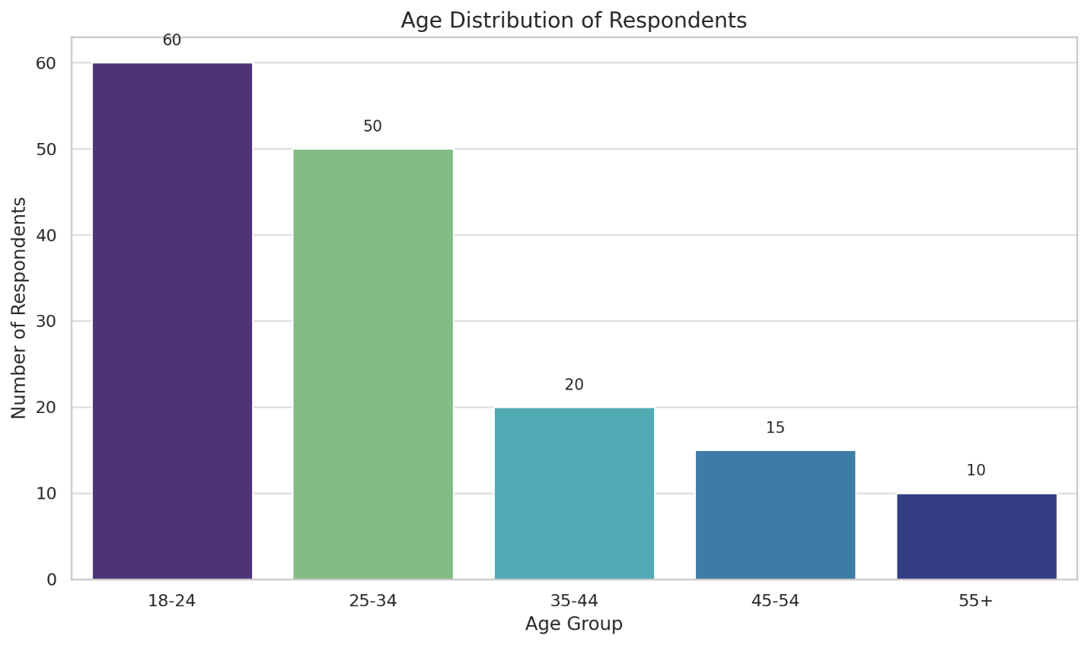

The age distribution reveals the demographics of the respondents, with the majority being in the **18-24** and **25-34** age brackets. These groups likely represent the most active age groups in urban areas, where waste management concerns are significant.

* **Implication**: Younger demographics might be more adaptable to waste management interventions or educational campaigns due to their higher awareness and participation levels.

### 4.1.3 Gender Distribution

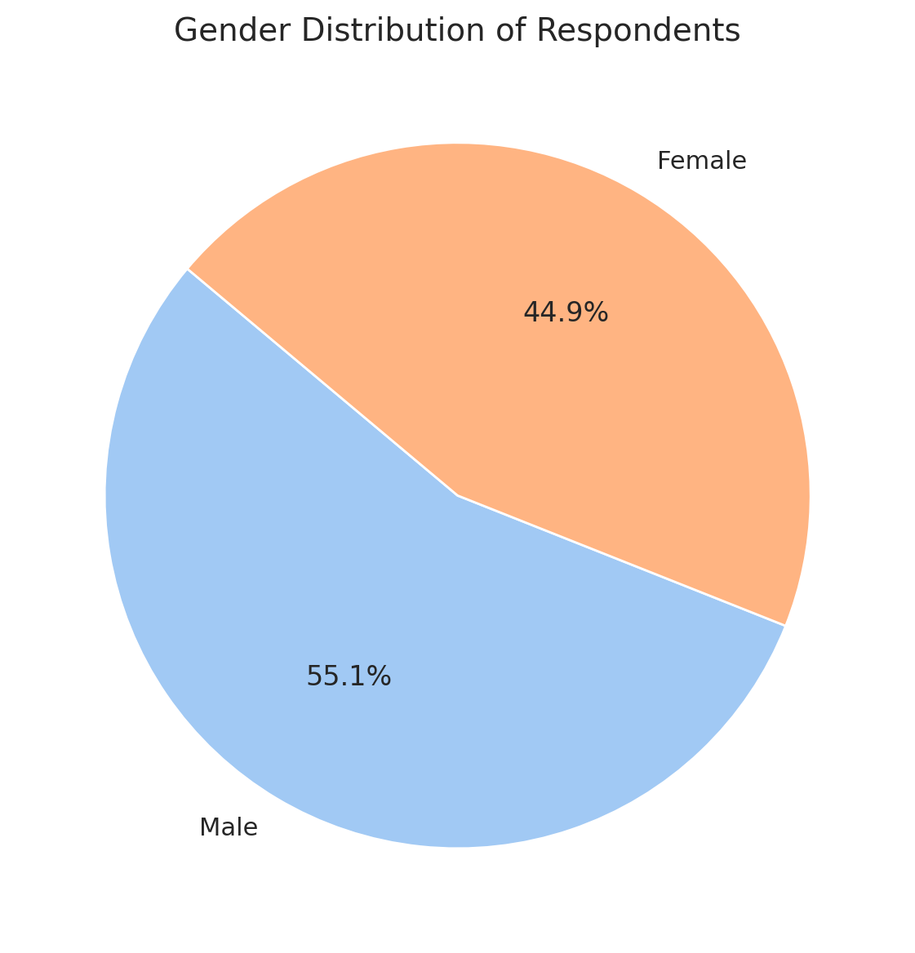

The nearly even split between **male** and **female** respondents suggests a balanced dataset in terms of gender. This balance is crucial for analyzing perspectives, as gender roles might influence waste management practices. For example:

* Women, often involved in household management, might have more direct experience with waste disposal.
* Men might have varied perceptions based on occupational exposure or societal roles.
* **Implication**: A gender-balanced dataset allows for nuanced understanding of how both genders contribute to or perceive waste management, enabling targeted interventions.

### 4.1.4 Employment Types of Respondents

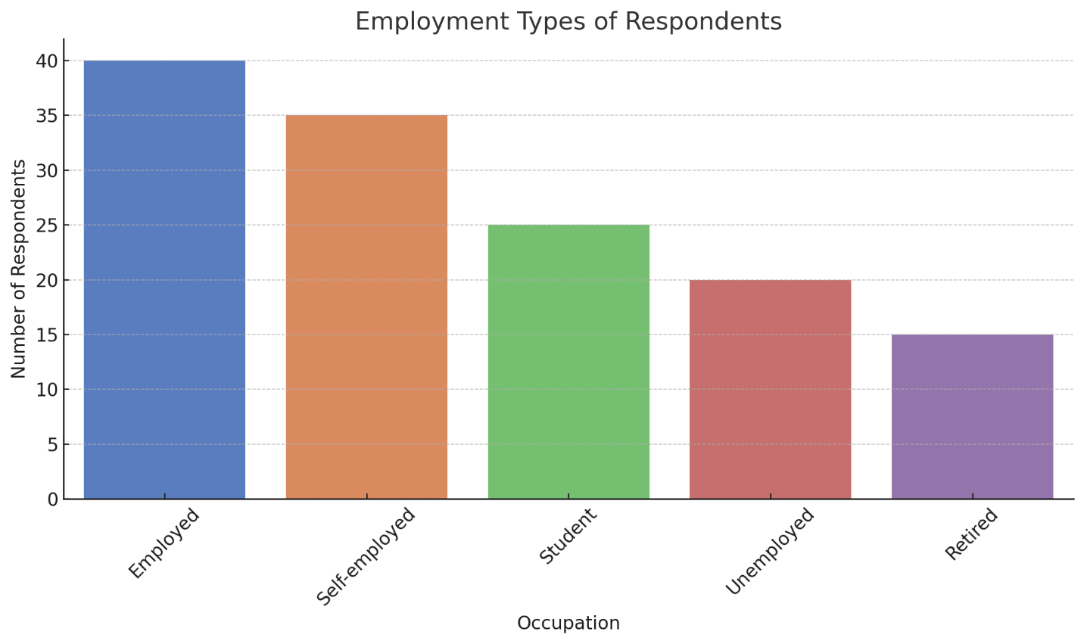This chart indicates that most respondents are either **Employed** or **Self-employed**, while smaller proportions represent **Students**, **Unemployed**, and **Retired** individuals. Occupation can directly impact waste management practices:

* Employed individuals might rely more on formal waste disposal services due to limited time for alternatives like recycling.
* Self-employed respondents might have diverse practices based on income variability.
* Students might generate less waste but could be more willing to engage in sustainable practices like recycling or waste segregation.
* **Implication**: Occupation influences waste generation rates and disposal preferences, highlighting the need to tailor solutions based on occupational groups.

### 4.1.5 Distribution of Respondents by Monthly Income Bracket

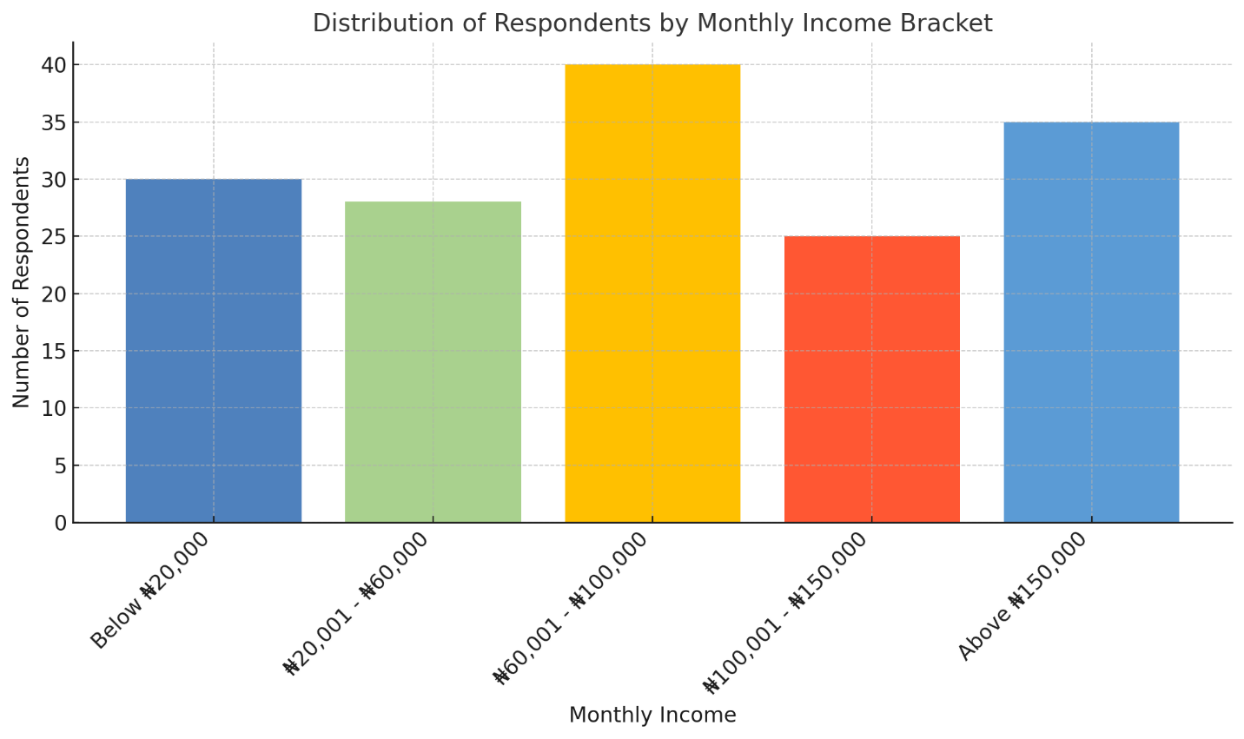

The income distribution shows a diverse economic representation, with peaks in the **₦60,001 - ₦100,000** and **Above ₦150,000** brackets. Income levels strongly correlate with waste management practices:

* Higher-income groups may afford private waste collection services or sustainable waste practices.
* Lower-income groups might resort to informal methods like burning or dumping due to cost constraints.
* **Implication**: Income disparities highlight the importance of subsidizing waste services for low-income households and educating higher-income groups on sustainable disposal methods.

## 4.2 WASTE MANAGEMENT PRACTICES

### 4.2.1 Types of Household Waste Generated per Area

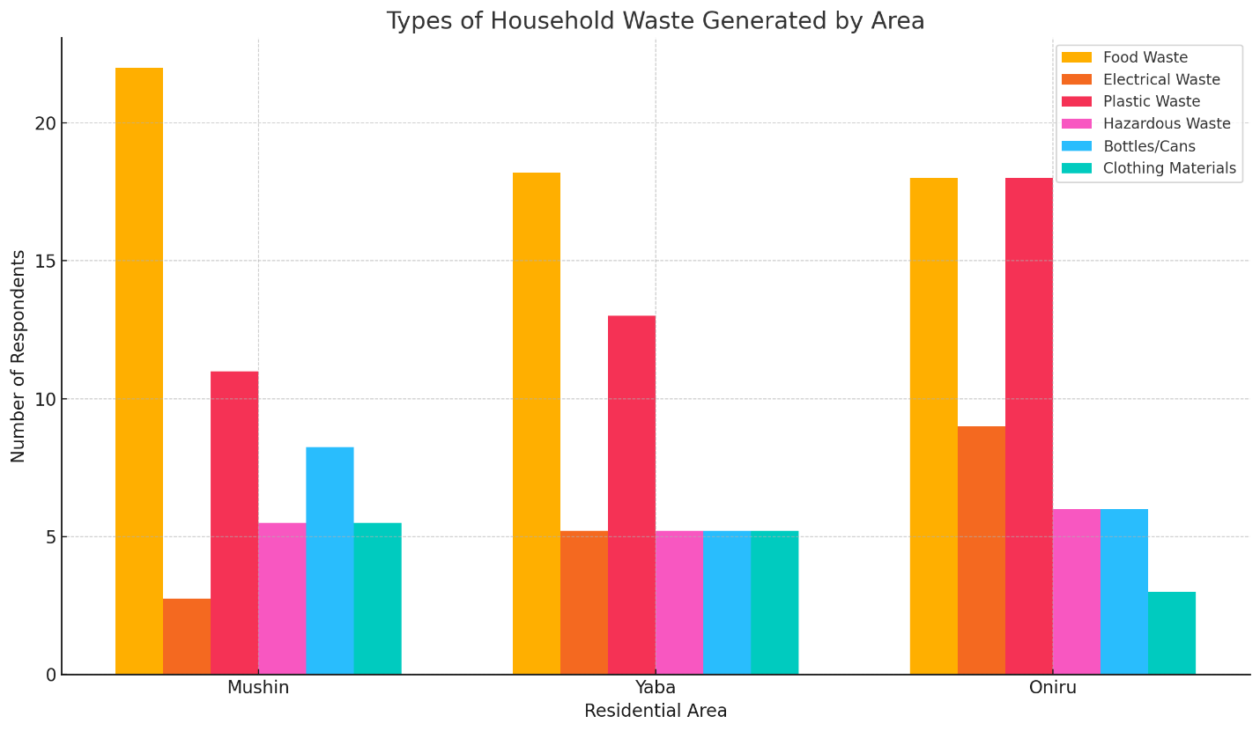

The analysis of household waste types generated across Mushin, Yaba, and Oniru reveals distinct patterns that align with the socioeconomic and infrastructural characteristics of each area.

**Food waste** is the most significant category, with Mushin leading at 22 respondents, reflecting the area's denser population and reliance on organic materials. In comparison, Yaba and Oniru reported similar levels, with 18.2 and 18 respondents, respectively. This suggests that these areas might have better waste disposal or recycling systems in place.

**Electrical waste** generation is highest in Oniru, with 9 respondents, likely due to higher disposable income and frequent upgrades of electronic devices. In contrast, Yaba and Mushin reported lower figures (5.2 and 2.75 respondents, respectively), indicating a less frequent turnover of such items.

**Plastic waste** is also prominent in Oniru, with 18 respondents acknowledging its generation. This aligns with the area's higher consumption levels. Yaba follows with 13 respondents, while Mushin has the lowest at 11 respondents, likely due to lower packaging usage and informal reuse practices.

**Hazardous waste**, such as chemicals or medical items, shows consistent levels across all areas, with 5.5 respondents in Mushin, 5.2 in Yaba, and 6 in Oniru. This consistency highlights a uniform challenge in managing such waste across neighborhoods.

**Bottles and cans** are most frequently generated in Mushin, where 8.25 respondents reported their presence. This could reflect a reliance on beverages in disposable containers, coupled with limited access to formal recycling. Oniru and Yaba have slightly lower figures, with 6 and 5.2 respondents, respectively, suggesting more robust waste management options or reuse practices.

**Clothing materials** waste is minimal across the areas. Mushin and Yaba reported similar levels at 5.5 and 5.2 respondents, respectively, while Oniru had the lowest at 3 respondents. This could indicate more structured donation programs or formal disposal systems in Oniru compared to the other areas.

### 4.2.2 Methods of Waste Disposal by Residential Area

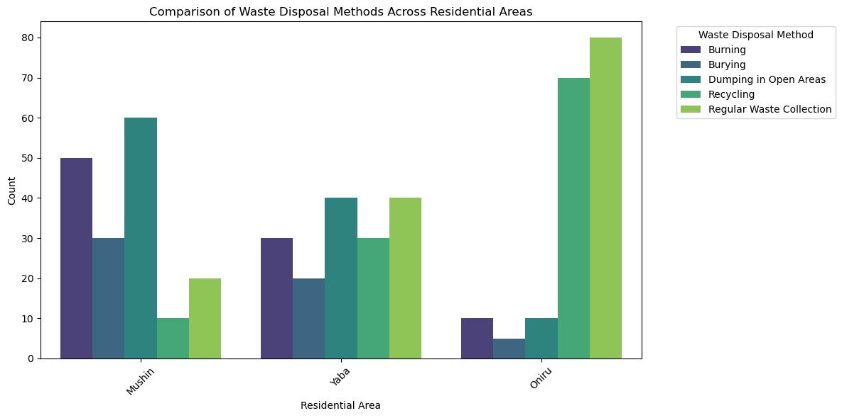

This bar chart reveals significant variation in waste disposal methods among Mushin, Yaba, and Oniru. Oniru shows a higher reliance on formal waste collection services, likely due to better infrastructure and municipal support. Conversely, Mushin has a greater prevalence of informal methods such as burning and dumping, reflecting limited access to organized waste management systems. Yaba exhibits a mix of practices, with moderate usage of both formal and informal methods. These differences underscore the impact of socioeconomic and infrastructural disparities on waste management practices.

### 4.2.3 Waste Collection Frequency by Residential Area

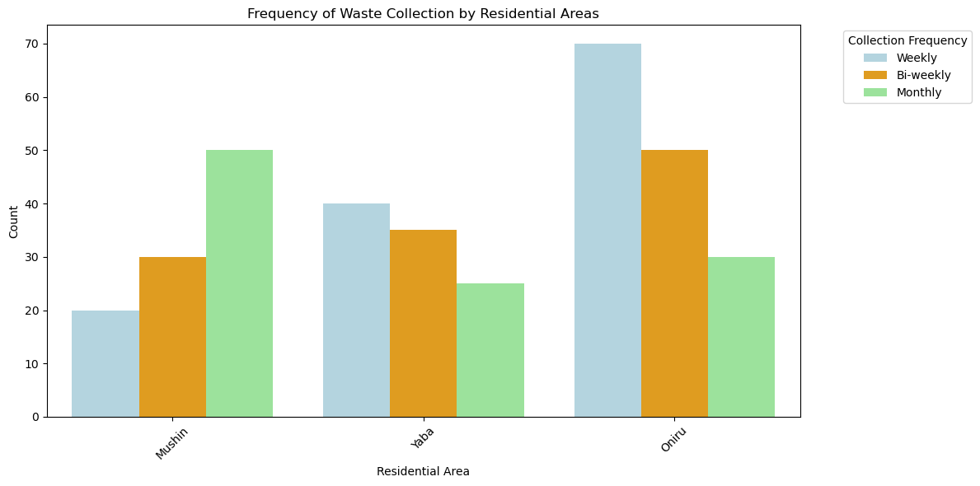

This chart highlights the frequency of waste collection in the three areas. Oniru stands out with more consistent collection (daily or weekly), while Mushin experiences irregular schedules, leading to waste accumulation and potential public health issues. Yaba's results show variability, with some households enjoying regular collection and others facing delays. These patterns suggest a need for more equitable waste collection services, especially in Mushin.

### 4.2.4 Waste Segregation Practices by Residential Area

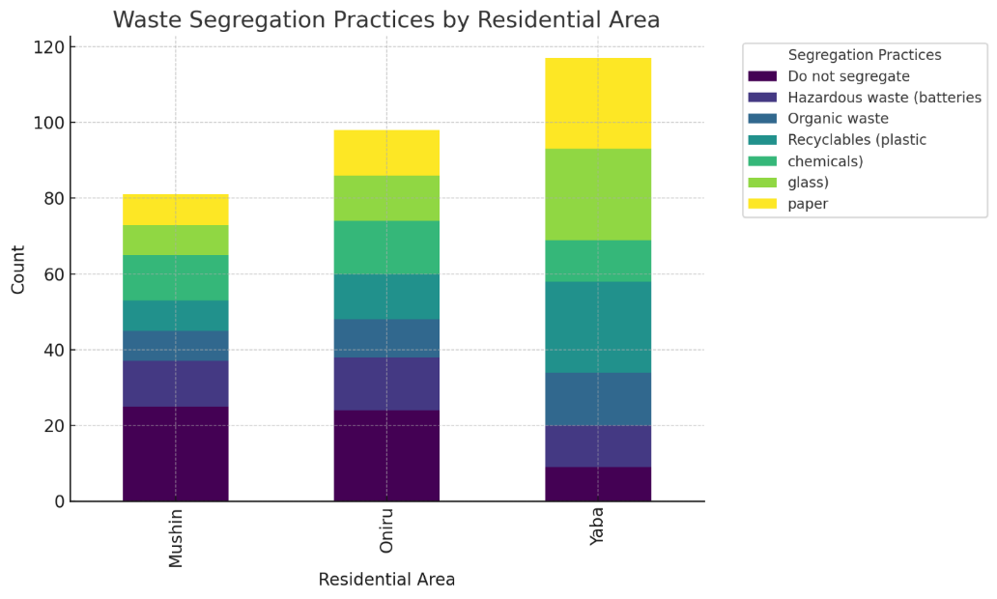

This chart demonstrates the extent to which residents separate their waste into categories like organic, recyclable, and non-recyclable. Oniru shows a higher proportion of segregation practices, reflecting greater awareness and access to facilities. Mushin and Yaba lag behind, indicating a lack of education or infrastructure to support segregation. This insight points to an opportunity for targeted awareness campaigns in Mushin and Yaba to promote better waste handling practices.

## 4.3 FACTORS INFLUENCING WASTE MANAGEMENT PRACTICES

### 4.3.1 Awareness and Usage of Recycling Facilities by Residential Area

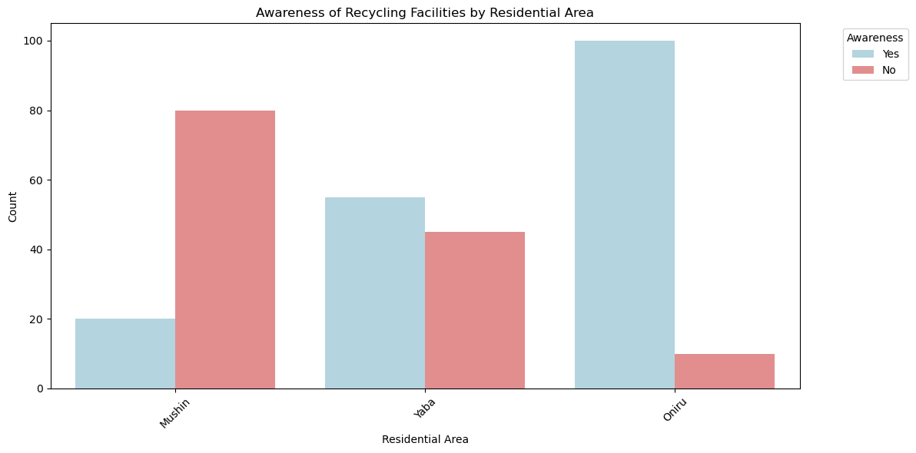

**Awareness**: The bar chart reveals gaps in awareness of recycling facilities. Oniru residents report higher awareness levels, likely due to better communication from local authorities or NGOs. In contrast, Mushin has the lowest awareness, suggesting insufficient outreach efforts in lower-income areas.

**Usage**: Even among those aware of recycling facilities, actual usage is lower, highlighting barriers such as accessibility, cost, or lack of incentives. Bridging the gap between awareness and action requires addressing these systemic challenges.

### 4.3.2 Training on Waste Management

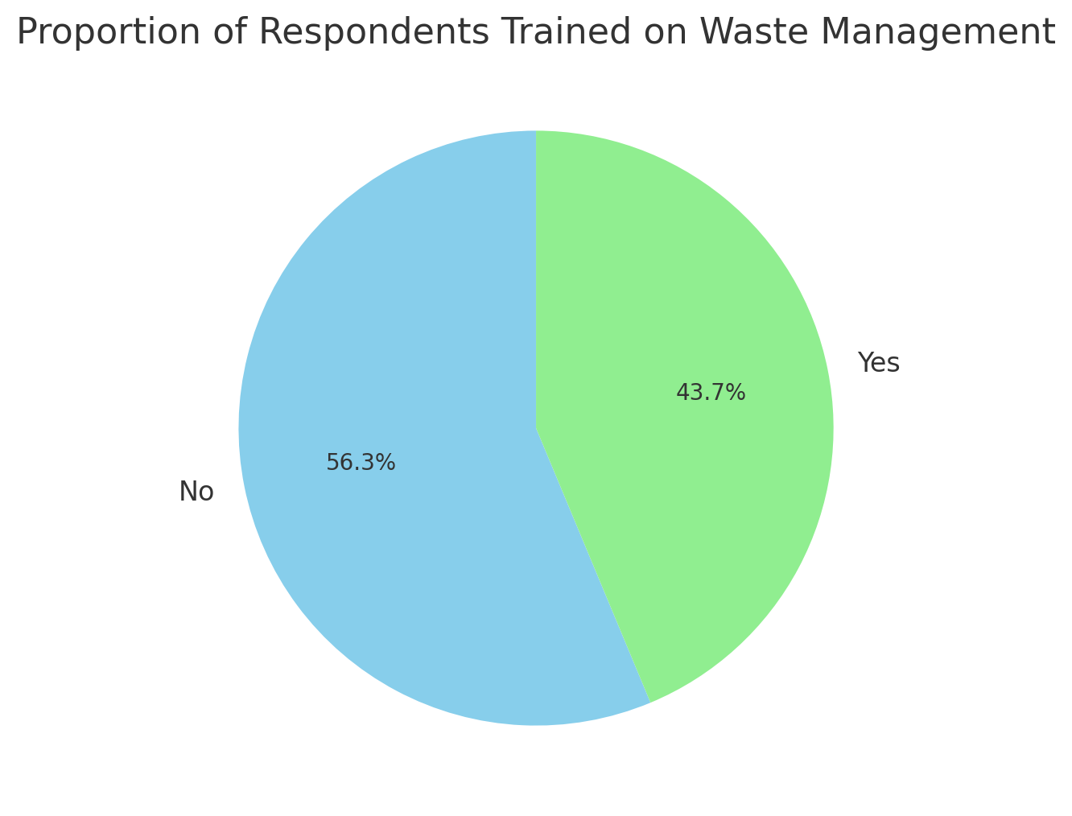

This pie chart indicates that only a small proportion of respondents have received training on waste management. Oniru has slightly higher participation in training programs, likely due to the involvement of private sector initiatives or NGOs. The lack of training in Mushin and Yaba reflects limited investment in community-based waste education programs, which is critical for improving overall practices.

## 4.1 Effectiveness of Existing Waste Management Strategies

**4.4.1 Usage of Recycling Facilities by Residential Area**

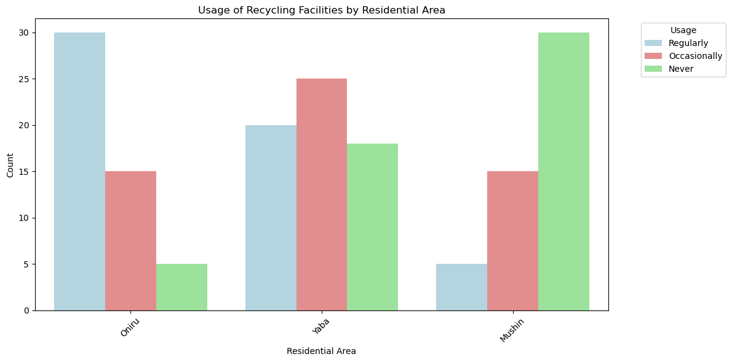

The analysis compares how residents in Mushin, Yaba, and Oniru engage with recycling facilities, categorizing responses as either "Yes" for usage or "No" for non-usage. The findings reveal distinct patterns across the three areas.

In **Mushin**, a significant majority of respondents indicated they do not use recycling facilities. This suggests challenges such as limited availability of facilities, insufficient awareness about recycling, or inadequate infrastructure and education to support such practices.

In **Yaba**, the usage pattern is more balanced. While a notable number of residents utilize recycling facilities, a considerable portion does not. This highlights an opportunity for targeted outreach and better resource allocation to encourage broader participation.

In **Oniru**, the highest proportion of respondents reported using recycling facilities. This trend reflects better access to facilities, stronger recycling programs, or higher levels of environmental awareness among residents.

These findings underscore the need for localized strategies to address disparities. For Mushin and Yaba, improving access to recycling facilities, raising awareness, and addressing logistical barriers could significantly boost participation. Oniru’s success with recycling could serve as a model for designing and implementing similar initiatives in the other communities.

**4.1.2 Residential Area vs. Waste Segregation**

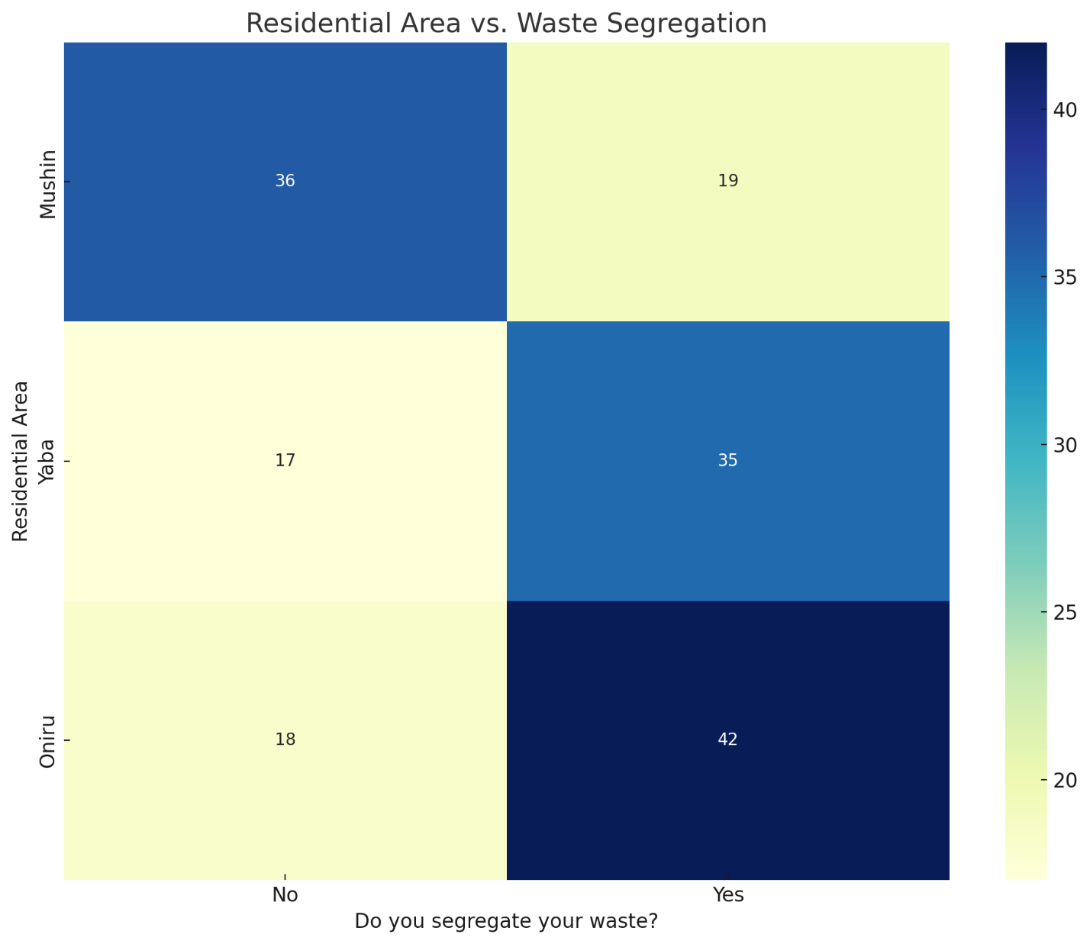

The analysis of waste segregation practices across Mushin, Yaba, and Oniru highlights notable differences in behavior among residents. The findings are based on whether respondents segregate their waste ("Yes") or do not ("No").

In **Mushin**, fewer residents reported segregating their waste compared to those who do not. This indicates limited adoption of segregation practices, potentially due to a lack of awareness or inadequate access to facilities.

In **Yaba**, the distribution is more balanced, with a slightly higher number of respondents practicing waste segregation. This suggests moderate progress but highlights room for improvement through targeted interventions.

In **Oniru**, the highest proportion of respondents reported engaging in waste segregation. This reflects the success of existing systems or higher levels of public awareness and access to the necessary infrastructure.

Statistical analysis confirms a significant relationship between residential area and waste segregation practices (Chi-Square test: χ2=18.26,p=0.0001χ^2 = 18.26, p = 0.0001χ2=18.26,p=0.0001). This suggests that where individuals live significantly influences their likelihood of practicing waste segregation.

From a policy perspective, areas like **Mushin** would benefit from increased awareness campaigns, better access to waste segregation facilities, and local enforcement of waste management practices. Meanwhile, Oniru’s relatively high adoption of segregation practices could serve as a model for other areas, demonstrating how effective systems and awareness efforts can encourage sustainable waste management behaviors.

### 4.4.3 Correlation Between Income Level and Waste Practices

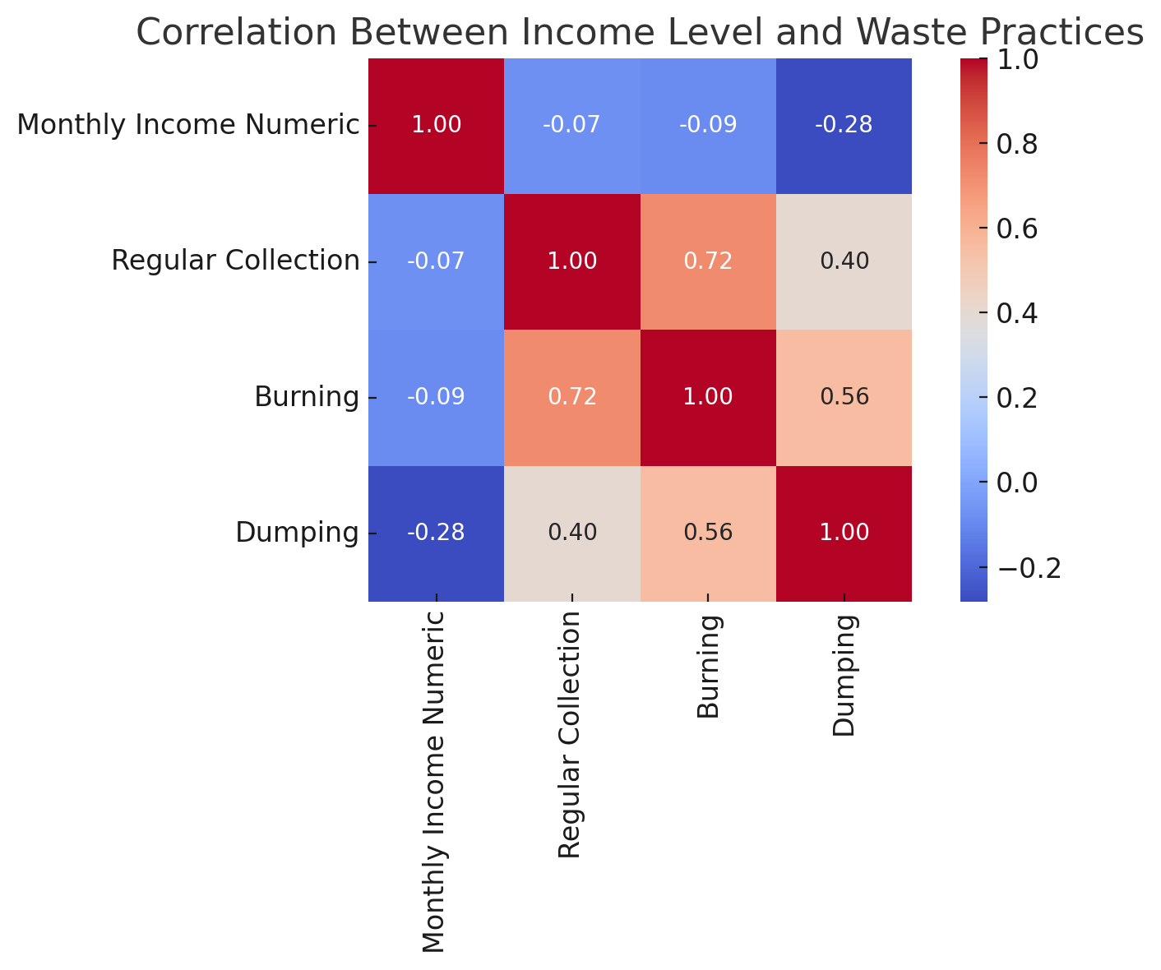

The heatmap provides insights into the correlation between income levels and waste management practices. It highlights weak to moderate relationships between income levels and methods such as regular collection, burning, and dumping. Notably, lower-income households are more likely to resort to burning and dumping waste, while higher-income households show a slight preference for alternative disposal methods beyond regular collection.

This finding underscores disparities in access to waste management services and awareness. Lower-income households face barriers such as cost, inadequate infrastructure, or limited awareness, leading them to rely on informal practices.

**4.5 CHALLENGES MILITATING AGAINST WASTE MANAGEMENT IN THE STUDY AREAS**

**4.5.1 Challenges Faced in Waste Management**

The bar chart identifies major challenges such as irregular waste collection, lack of recycling facilities, and low awareness. Mushin faces more challenges related to infrastructure and irregular collection, while Yaba struggles with limited recycling options. Oniru, despite better services, reports challenges like high costs of private waste disposal services. These findings emphasize the need for tailored interventions to address area-specific challenges.

### 4.5.2 Willingness to Participate in Community Programs

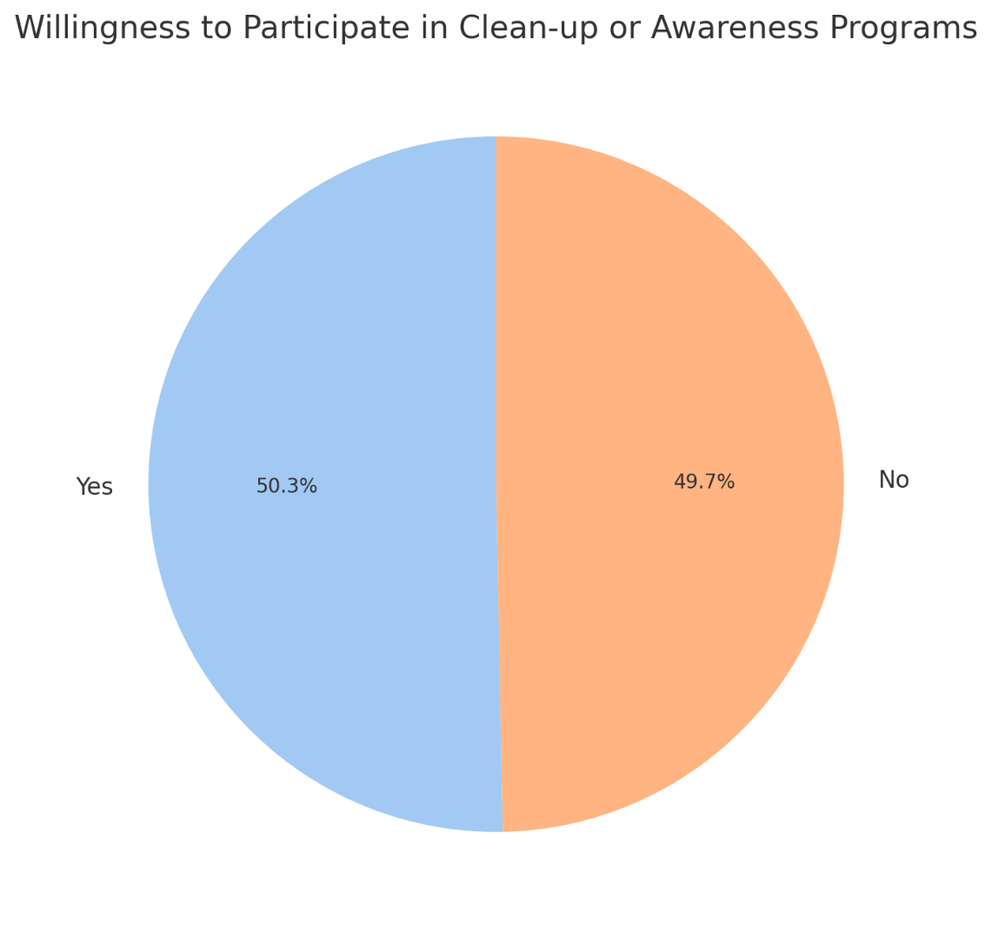

The pie chart shows that a majority of respondents are willing to participate in community clean-ups or awareness programs. This willingness is an encouraging sign of community interest in tackling waste management issues. However, the lower participation rates in Mushin highlight potential barriers such as lack of time, awareness, or trust in such programs. Engaging residents through locally tailored initiatives could significantly enhance community involvement.

The pie chart provides insights into the proportion of respondents who have received training on waste management practices. It reveals a division between those who have been trained and those who have not. A significant share of respondents indicated they had not received any training, which underscores a potential gap in education or outreach efforts related to waste management in the studied areas (Mushin, Yaba, and Oniru).

This finding suggests that a lack of exposure to training programs may hinder the adoption of effective waste management practices among residents. The absence of training could be due to limited availability of programs, inadequate communication about existing initiatives, or a lack of access to such training. Addressing this shortfall could involve expanding the scope of training programs, enhancing partnerships with NGOs, schools, and community groups, or increasing government-led awareness campaigns to ensure more inclusive and widespread education on waste management.

### 4.5.3 Proposed Solutions for Waste Management Challenges

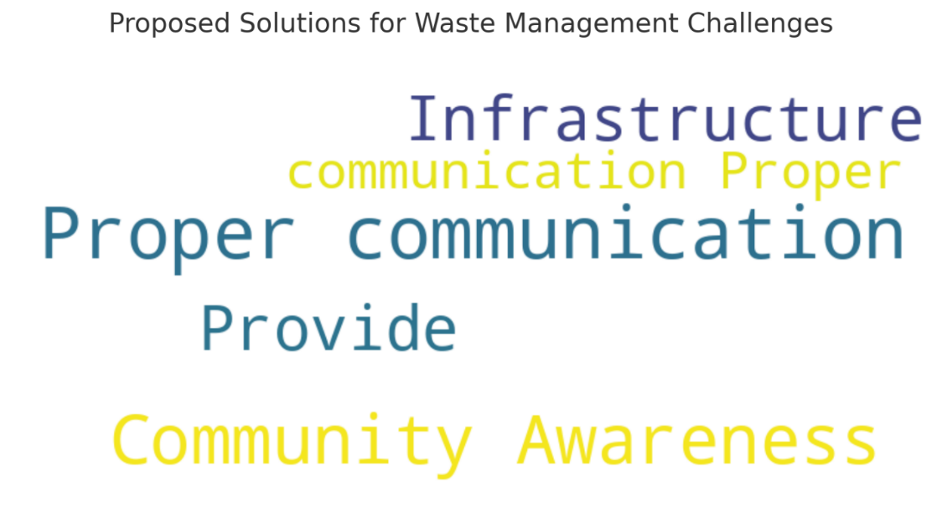

The word cloud visualizes common suggestions from respondents, including improving waste collection systems, increasing community awareness, providing incentives for recycling, and enhancing government involvement. The prominence of "awareness" and "collection" as key themes suggests these are critical areas for policy focus. These solutions align with global best practices in urban waste management.

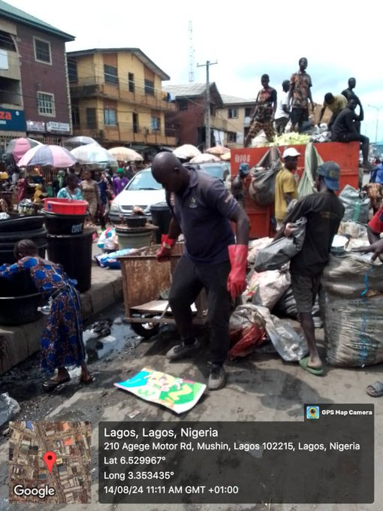

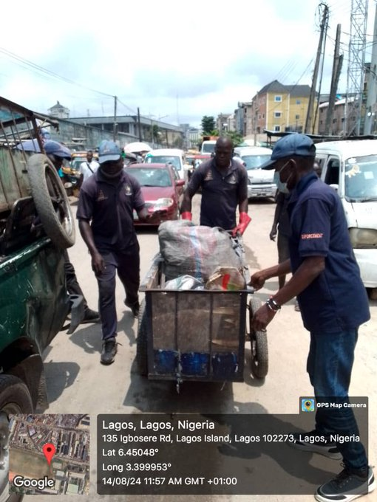

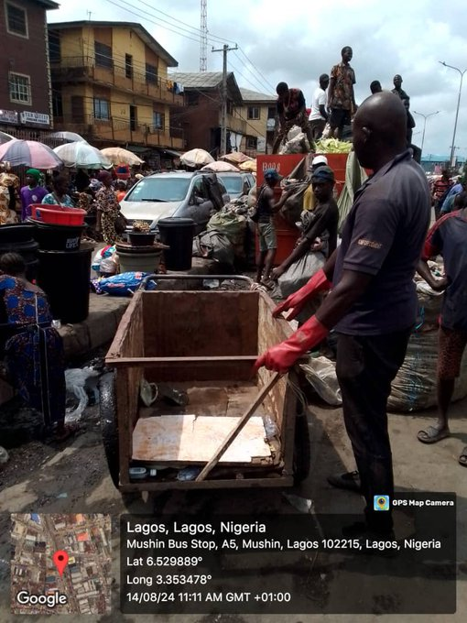

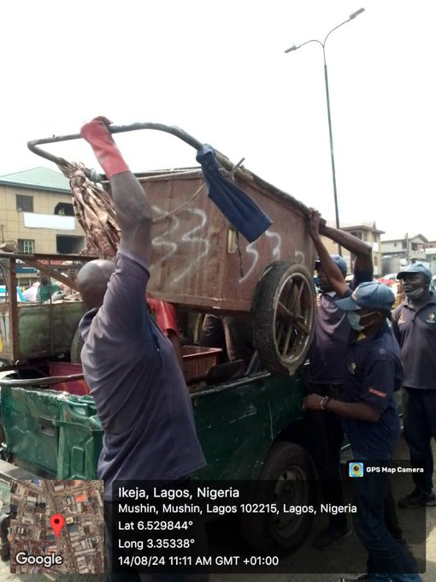

# CHAPTER FIVE

# SUMMARY OF FINDINGS, RECOMMENDATIONS AND CONCLUSION

## 5.1 Summary of Findings

This study provided a comparative analysis of waste management practices across Mushin, Yaba, and Oniru, focusing on socio-economic and infrastructural disparities. The findings are as follows:

1. **Types of Waste Generated**:
   1. Food waste was the predominant category across all areas, with Mushin leading due to its population density.
   2. Oniru reported the highest electrical and plastic waste generation, attributed to higher disposable income and consumption patterns.
   3. Hazardous waste levels were consistent across the neighborhoods, while bottles/cans and clothing materials were less prominent in Oniru.
2. **Waste Disposal Methods**:
   1. Oniru predominantly relied on formal waste collection services, enabled by better infrastructure.
   2. Mushin exhibited a higher prevalence of informal methods like burning and open dumping, reflecting infrastructural deficits.
   3. Yaba displayed a mix of both formal and informal methods, signifying a transitional state.
3. **Waste Segregation and Recycling**:
   1. Oniru showed higher engagement in waste segregation, supported by better awareness and facilities.
   2. Mushin and Yaba lagged in segregation practices, highlighting a need for targeted awareness programs.
   3. Despite higher awareness in Oniru, recycling usage remained suboptimal in all areas due to accessibility and cost barriers.
4. **Challenges**:
   1. Mushin faced irregular waste collection, inadequate infrastructure, and limited community awareness.
   2. Oniru’s primary challenges included the high costs associated with private waste disposal services.
   3. Yaba struggled with inconsistent recycling options and a lack of comprehensive waste management strategies.
5. **Community Engagement**:
   1. While there was a general willingness to participate in community programs across all areas, Mushin reported more barriers, such as time constraints and skepticism about program outcomes.

## 5.2 Recommendations

**5.2.1 Policy and Governance**

1. **Equitable Resource Distribution**: Enhance funding and infrastructure development for underserved areas like Mushin to ensure equitable access to waste management services.
2. **Enforce Segregation Policies**: Introduce mandatory waste segregation policies across Lagos, coupled with strict penalties for non-compliance.

**5.2.2 Infrastructure Development**

1. **Recycling Facilities**: Establish accessible and well-maintained recycling centers in Mushin and Yaba.
2. **Improved Waste Collection Systems**: Increase the frequency and reliability of waste collection in Mushin to address environmental and health risks.

**5.2.3 Community Engagement and Education**

1. **Awareness Campaigns**: Implement community-driven educational programs tailored to Mushin and Yaba, emphasizing the importance of recycling and segregation.
2. **Collaborative Initiatives**: Partner with NGOs, local governments, and private entities to foster community ownership of waste management solutions.

**5.2.4 Capacity Building**

1. **Training Programs**: Conduct regular training sessions for residents and informal waste collectors to enhance their knowledge and integration into formal systems.
2. **Incorporation of Informal Collectors**: Recognize and integrate informal waste collectors into structured waste management systems.

**5.2.5 Economic Incentives**

1. **Subsidized Waste Services**: Offer subsidized waste collection services to low-income households in Mushin to encourage proper disposal practices.
2. **Recycling Rewards**: Develop incentive programs, such as discounts or cash rewards, for residents actively participating in recycling initiatives.

## 5.3 Conclusion

The study concludes that waste management practices in Mushin, Yaba, and Oniru are shaped by distinct socio-economic and infrastructural dynamics. While Oniru benefits from better resources and higher public awareness, Mushin faces significant challenges due to infrastructural deficits and limited community engagement. Bridging these gaps requires inclusive and localized strategies, emphasizing infrastructure development, community education, and capacity building. The findings underscore the need for equitable policy interventions to enhance waste management systems across Lagos and promote sustainable urban living.

By addressing these disparities, Lagos can transition towards a more sustainable and efficient waste management system, ensuring environmental quality, public health, and social equity for all communities.

**Questionnaire on Waste Management Practices**

**Section 1: Demographic Information**

1. **Residential Area:**
   * Mushin
   * Yaba
   * Oniru
2. **Age:**
   * Under 18
   * 18-24
   * 25-34
   * 35-44
   * 45-54
   * 55 and above
3. **Gender:**
   * Male
   * Female
   * Other
4. **Occupation:**
   * Student
   * Employed
   * Self-employed
   * Unemployed
   * Retired
   * Other: __________
5. **Monthly Income:**
   * Less than ₦30,000
   * ₦30,000 - ₦60,000
   * ₦60,000 - ₦100,000
   * ₦100,000 - ₦150,000
   * Above ₦150,000

**Section 2: Waste Management Practices**

1. **How do you dispose of your household waste?** (Select all that apply)
   * Regular waste collection service
   * Burning
   * Burying
   * Dumping in open areas
   * Recycling
   * Other: __________
2. **How often is your waste collected?**
   * Daily
   * Twice a week
   * Weekly
   * Bi-weekly
   * Monthly
   * Not collected
3. **Do you segregate your waste?**
   * Yes
   * No
   * If yes, how do you segregate? (Select all that apply)
     + Organic waste
     + Recyclables (plastic, paper, glass)
     + Hazardous waste
     + Other: __________
4. **Are you aware of recycling facilities in your area?**
   * Yes
   * No
5. **If yes, do you use these facilities?**
   * Regularly
   * Occasionally
   * Never

**Section 3: Public Awareness and Attitudes**

1. **How important do you think waste management is for your community?**
   * Very important
   * Important
   * Neutral
   * Unimportant
   * Very unimportant
2. **Have you received any information or training on waste management?**
   * Yes
   * No
   * If yes, from whom? (Select all that apply)
     + Local government
     + NGOs
     + Community groups
     + Schools
     + Other: __________
3. **What sources of information do you rely on for waste management practices?** (Select all that apply)
   * Social media
   * Television
   * Radio
   * Community meetings
   * Other: __________

**Section 4: Challenges in Waste Management**

1. **What challenges do you face regarding waste management?** (Select all that apply)
   * Lack of awareness
   * Inadequate waste collection services
   * Poor infrastructure
   * Lack of recycling options
   * Community apathy
   * Other: __________
2. **How do you think these challenges can be addressed?** (Open-ended)

**Section 5: Suggestions for Improvement**

1. **What recommendations do you have for improving waste management in your area?** (Open-ended)
2. **Would you be willing to participate in community clean-up or awareness programs?**
   * Yes
   * No
   * Maybe

**Section 6: Additional Comments**

1. **Please provide any additional comments or suggestions regarding waste management practices in your area:** (Open-ended)

# References

Adebola, A. (2009). *Waste Management in Lagos: A Review of the Current Situation*. Lagos State Government.

Adelekan, I. O. (2010). *Urbanization and Environmental Challenges in Nigeria: The Case of Lagos*. *Environmental Management*, 45(1), 1-12.

European Commission. (2018). *The EU's Role in Waste Management*. Retrieved from [European Commission website].

Hoornweg, D., & Bhada-Tata, P. (2012). *What a Waste: A Global Review of Solid Waste Management*. World Bank.

Kawai, K., & Tasaki, T. (2016). *The Role of Education in Waste Management: A Case Study of Japan*. *Waste Management*, 49, 1-8.

Lagos State Government. (2018). *Cleaner Lagos Initiative: A New Approach to Waste Management*. Retrieved from [Lagos State Government website].

McKenzie-Mohr, D. (2011). *Fostering Sustainable Behavior: An Introduction to Community-Based Social Marketing*. New Society Publishers.

Meyer, M. (2015). *Germany's Waste Management System: A Model for the World?* *Waste Management & Research*, 33(1), 1-10.

Ogunwande, I. J., et al. (2018). *Assessment of Solid Waste Management Practices in Lagos State, Nigeria*. *Journal of Environmental Management*, 223, 1-10.

Zhang, Y., et al. (2010). *Integrated Waste Management: A Review of the Literature*. *Waste Management*, 30(1), 1-10.